

ELABORATION PHASE SPECIFICATION

**TLC**

William Brown • Cameron Duffy • Joseph Eckl

Zac Endicott • Savanah Kennedy • Ryan Smith

System Requirements

This document provides the current functional and nonfunctional requirements for the requested system, cloud storage system, and website to be created. Requirements are organized in a hierarchy, and ranked by importance.

**Functional Requirements**

1. The cloud storage system will back up all important and prominent data to allow for recovery and business continuity.
2. The website will incorporate an online payment system, so the KHBPA can receive donations online.
3. The website will push content and news to users to cut postage costs.
4. The website will be able to generate reports for users.
5. The website will have a form so members can register online.
6. The website will contact users when they need to be contacted, such as when a report request has been filled.
7. The website will give medicine change notices.
8. The website will include a dashboard about races (delays, track conditions, etc.).
9. The website will have an “about us” page that will describe their mission statement and the services the KHBPA offers.
10. The website will have board member biography pages that contain photographs, short biographies, and contact information of key board members.
11. The website will have a calendar of events page.
12. The website will have a page with membership benefits and an outline of membership requirements.
13. The website will have a tool to poll members for decision making.
14. The website will have a page for meeting minutes between the horsemen committee members.
15. The website will have a page with links to partner organizations such as TAA, the KY Race Tracks, and contact information for each partner.
16. The website will be directly integrated with the KHBPA social media accounts.
17. The website will host a blog.
18. The website will have a message from the president page.
19. The website will be mobile compatible.
20. The website will have a racing/gambling education page.
21. The website will allow members to upload photos to the website after the photo has been approved by a KHBPA employee.
22. The website will have a photo gallery of relevant photos.

**Nonfunctional Requirements**

1. Any code written for the website will use a CMS (WordPress).
2. Website content will be easily editable by employees of KHBPA.
3. The website will be progressive, youthful, and marketable (“shock and awe”)
4. The website will be visually distinct from similar organizations.

Use Case Diagram

Three use case diagrams follow. They are for the high, medium, and low-importance levels.

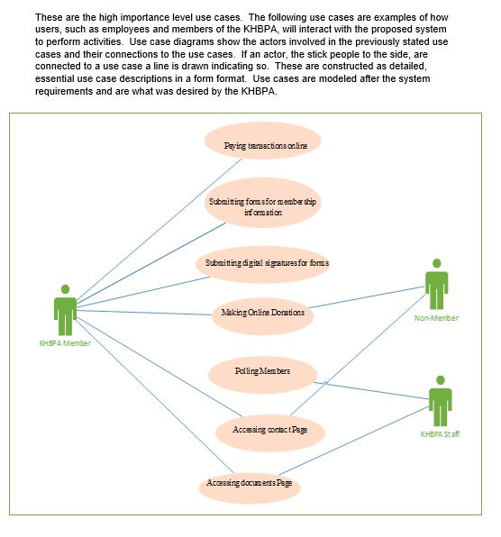

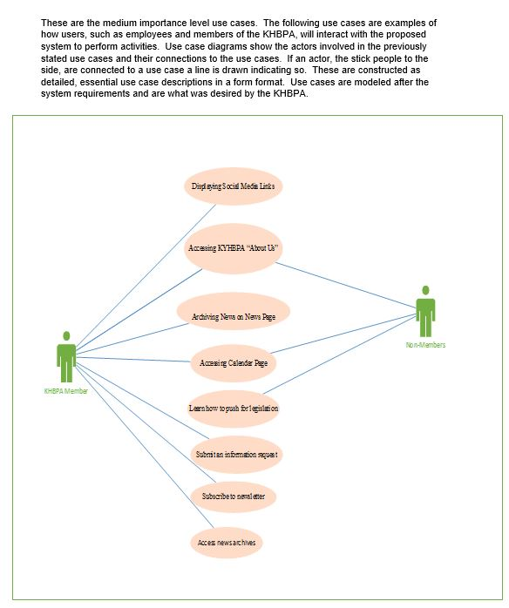

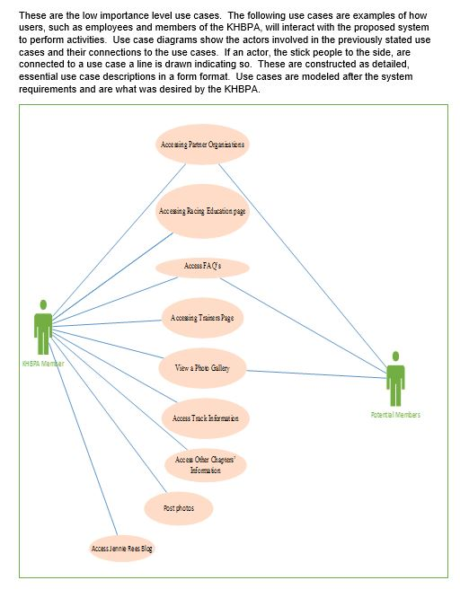

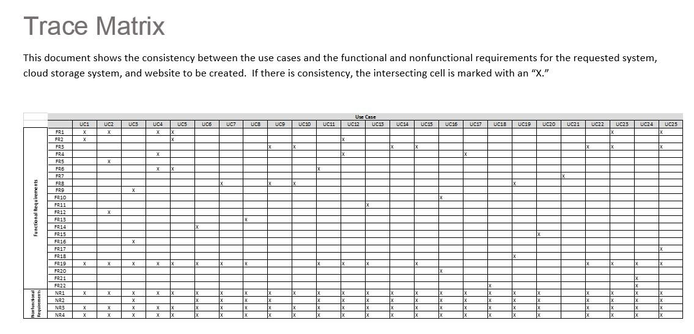

Use Cases

Use Cases Narrative: The following use cases are examples of how users, such as employees and members of the KHBPA, will interact with the proposed system to perform activities. These are constructed as detailed, essential use case descriptions in a form format. Use cases are modeled after the system requirements and are what was desired by the KHBPA.

**Use Case Name:** Paying Transactions Online **ID:** 01 **Importance Level**: High

**Primary Actors**: Donors, Members-to-be, License Applicants **Use Case Type**: Detail, Essential

**Stakeholders and Interests**:

KHBPA - Receives payment from

Donors -Wants to donate to KHBPA

License Applicants - Wants to receive a license from KHBPA

**Brief Description**: Online transactions for forms and donations are needed to provide a quick and automated service for the users to enter their credentials for the transaction. Also, must be secured to ensure the user's information cannot be accessed from external threats.

**Trigger**: Member clicks button on transaction payment page

**Type**: External

**Relationships**:

**Association**: PayPal

**Include**:

**Extend**: Receiving transactions online with PayPal

**Generalization**:

**Normal Flow of Events:**

1. Access to KHBPA website homepage
2. Access to donation page or license application on form page
3. Service provided after a form has been filled out

**Use Case Name:** Submitting Forms for Membership Information **ID:** 02 **Importance Level**: High

**Primary Actors**: Members-to-be **Use Case Type**: Detail, Essential

**Stakeholders and Interests**:

· KHBPA - Wants easy and organized storage of member information

· Member-to-be - Wants to become a member of KHBPA

**Brief Description**: Membership to the KHBPA would be increased due to the ease of access and entry of the user’s information required for the membership. Forms would provide a simple service to the users who previously would have to submit a paper copy to the offices.

**Trigger**: Member clicks submit button on form

**Type**: External

**Relationships**:

**Association**: KHBPA

**Include**:

**Extend**: Collecting and storing member information through form

**Generalization**:

**Normal Flow of Events:**

1. Access to KHBPA website homepage

2. Access to form page through tab bar

3. Access to membership form through link on page

**Use Case Name:** Displaying Social Media Links **ID:** 03 **Importance**: Medium

**Primary Actors**: Visitors, Members **Use Case Type**: Detail, Essential

**Stakeholders and Interests**:

KHBPA - Display links to social media pages for publicity and up-to-date news

Visitors- Looking for more information on KHBPA and events

Members- Looking for more information on KHBPA and events

**Brief Description**: Social media has become a massive portion of marketing so for the KHBPA to implement a way to connect their website to their social media links would greatly impact their communication not only with members but with the general public as well.

**Trigger**: Member clicks link to page

**Type**: External

**Relationships**:

**Association**: KHBPA

**Include**:

**Extend**: Marketing of Social Media Links to website users

**Generalization**:

**Normal Flow of Events:**

1. Access through KHBPA website homepage

2. Access to news page through tab bar

3. Access to links at bottom of news page

**Use Case Name:** Submitting Digital Signatures for Forms **ID:** 04 **Importance**: High

**Primary Actors**: Members-to-be **Use Case Type**: Detail, Essential

**Stakeholders and Interests**:

KHBPA – Wants to be protected from legal ramifications with online signatures

Member-to-be – Wants to be able to donate or pay for licensing

**Brief Description**: Some forms that the KHBPA will provide need a service for electronic signatures. These will be used to help with any legal issues that might arise with the documentation of the submission.

**Trigger**: Member tries to submit form for membership or license application

**Type**: External

**Relationships**:

**Association**: KHBPA

**Include**: Protection from audits of signed forms or licenses

**Extend**:

**Generalization**:

**Normal Flow of Events:**

1. Access through KHBPA website homepage
2. Access to form page through a tab bar
3. Access to form through link on form page
4. Electronic signature at the end of the form

**Use Case Name:** Making Online Donations **ID:** 05 **Importance Level:** High

**Primary Actor:** Donors **Use Case Type:** Detail, Essential

**Stakeholders and Interests**:

**Donor** – Wants to contribute to the KHBPA and support their mission

**KHBPA** – Wants to accept contributions to continue providing their services

**Brief Description:** This use case describes how donors can make an online donation through the KHBPA website.

**Trigger:** Donor visits website and makes a donation

**Type:** External

**Relationships**:

**Association:** Donor, KHBPA

**Include**:

**Extend:**

**Generalization:**

**Normal Flow of Events:**

1. Donor access KHBPA website
2. Donor navigates to “Donation” Page
3. Donor types donation amount into textbox
4. Donor clicks “Donate” button
5. Donor makes payment through online payment processing system
6. KHBPA sends confirmation of donation

**SubFlows:**

S-1: Payment fails

1. The online payment does not succeed.

2. Online payment processor sends donor notice of failure.

Making Online Donations Sequence Diagram

This diagram shows the interactions between classes in the Making Online Donation use case. Interactions are arrows which are labeled.

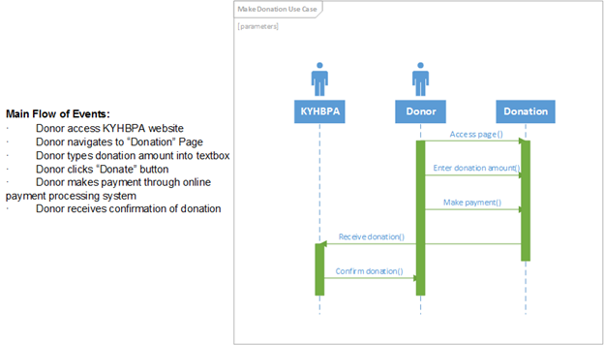

**Use Case Name:** Accessing Partner Organizations **ID:** 06 **Importance Level:** Low

**Primary Actor:** Members, Potential Members **Use Case Type:** Detail, Essential

**Stakeholders and Interests:**

Member – Wants to gain information or utilize services of partners of the KHBPA

KHBPA – Wants to allow members to access the services of their partners

**Brief Description:** This use case describes how members can gain information and utilize the services of the KHBPA’s partners

**Trigger:** Member visits website looking for information

**Type:** External

**Relationships**:

**Association:** Member, Potential Member

**Include**:

**Extend:**

**Generalization:**

**Normal Flow of Events:**

1. Member accesses KHBPA website.
2. Member navigates to “Partners” page.
3. Member clicks on the organization they are interested in.
4. Member is redirected to that organization's website.
5. Member obtains information and services from that website.

Accessing Partner Organization Sequence Diagram

This diagram shows the interactions between classes in the Accessing Partner Organization use case. Interactions are arrows which are labeled.

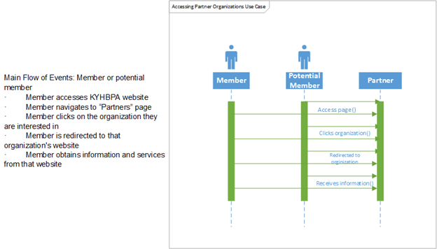

**Use Case Name:** Accessing KHBPA “About Us” **ID:** 07 **Importance Level:** Medium

**Primary Actor:** Members, Potential Members **Use Case Type:** Detail, Essential

**Stakeholders and Interests:**

Potential Member – Wants to gain information about the KHBPA

Member – Wants to gain information about the KHBPA

KHBPA – Wants to clearly give members and potential members an understanding of the organization and what their purpose is

**Brief Description:** This use case describes how members and potential members can gain information about the KHBPA

**Trigger:** Member or potential member visits website looking for information

**Type:** External

**Relationships**:

**Association:** Member, Potential Member

**Include**:

**Extend:**

**Generalization:**

**Normal Flow of Events:**

1. Member accesses KHBPA website
2. Member navigates to “About Us” page
3. Member looks for the information they desire
4. Member obtains information
5. Member clicks on “Contact Us” if they have a more detailed inquiry

Accessing “About Us” Sequence Diagram

This diagram shows the interactions between classes in the Accessing KHBPA “About Us” use case. Interactions are arrows which are labeled.

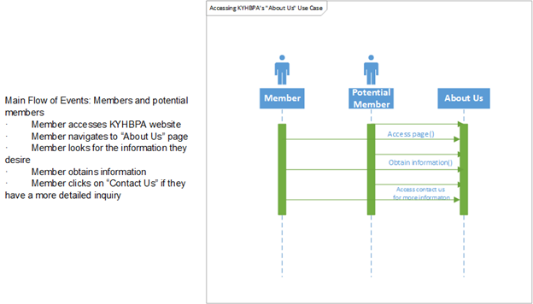

**Use Case Name:** Polling Members **ID:** 08 **Importance Level:** High

**Primary Actor:** Members, KHBPA **Use Case Type:** Detail, Essential

**Stakeholders and Interests:**

Member – Wants to give input to the KHBPA

KHBPA – Wants to establish clarity on members’ opinions on important industry topics

**Brief Description:** This use case describes how the KHBPA can poll its members.

**Trigger:** KHBPA sends e-mail to members requesting a poll be done

**Type:** External

**Relationships**:

**Association:** Member, KHBPA

**Include**:

**Extend:**

**Generalization:**

**Normal Flow of Events:**

1. KHBPA sends e-mail to member.
2. Member opens e-mail.
3. Member clicks link to poll.
4. Member fills out poll.
5. Member submits poll.
6. KHBPA reviews poll results.

Polling Members Sequence Diagram

This diagram shows the interactions between classes in the Polling Members use case. Interactions are arrows which are labeled.

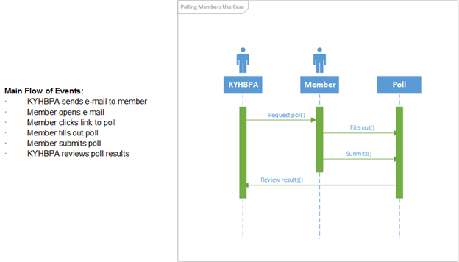

**Use Case Name:** Managing News Page **ID:** 09 **Importance Level:** High

**Primary Actor:** KHBPA **Use Case Type:** Detail, Essential

**Stakeholders and Interests**:

KHBPA - Wants to push current and accurate news out to users.

Members -Want to have a one-stop-source for current KHBPA related news relevant to them.

Non-Members -Want to find current insight on the KHBPA without too much searching to learn more.

**Brief Description:** This use case describes how KHBPA updates their news page with new articles, edit existing articles, and delete articles for any reason.

**Trigger:** KHBPA sees need to publish new article, share an article, make corrections to existing article, or delete an article.

**Type:** External

**Relationships**:

**Association:** KHBPA

**Include**:

**Extend:** Archiving News on News Page

**Generalization:**

**Normal Flow of Events:**

1. KHBPA writes news story.
2. KHBPA uploads news to the website.
3. Users read news on KHBPA’s news page.

**Sub Flows:**

S-1: Share News Story

1. KHBPA finds relevant news article.
2. KHBPA uploads news article.

If user clicks article link

User taken to news publication’s website to read article.

If user stay on page

User able to read news on KHBPA’s news page.

S-2: Edit News Story

1. KHBPA makes necessary edits to news article.
2. KHBPA republishes news article.

S-3: Delete News Story

1. KHBPA removes article from News Page.

This diagram shows the interactions between classes in the Manage News Page use case. Interactions are arrows which are labeled.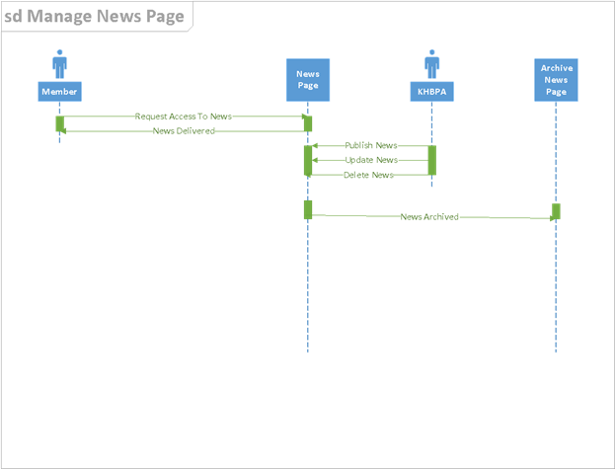

**Main Flow of Events:**

1. KHBPA writes news story.
2. KHBPA uploads news to the website.
3. Users read news on KHBPA’s news page.

**Use Case Name:** Archiving News on News Page **ID:** 10 **Importance Level:** Medium

**Primary Actor:** KHBPA **Use Case Type:** Detail, Essential

**Stakeholders and Interests**:

KHBPA - Wants a means to catalogue older news articles.

Members/Non-Members -Want to be able to separate current articles from past articles.

**Brief Description:** This use case describes how the system will archive KHBPA’s older articles.

**Trigger:** Article’s publish date reaches three months old.

**Type:** Temporal

**Relationships**:

**Association:** KHBPA

**Include**:

**Extend:**

**Generalization:** Manage News Page

**Normal Flow of Events:**

1. Article on News Page reaches three months of age.
2. Article is moved to archive folder separated by month/year.

**Sub Flows:**

S-1: KHBPA Employee Manually Moves Article

1. KHBPA selects article on News Page.
2. Article is placed in archive folder.



**Use Case Name:** Accessing Contact Page **ID:** 11 **Importance Level:** High

**Primary Actor:** Members/Non-Members **Use Case Type:** Detail, Essential

**Stakeholders and Interests**:

KHBPA - Want members and non-members to have means of contacting them for inquiries.

Members/Non-Members -Want a means to contact KHBPA for inquiries.

**Brief Description:** This page will have links to contact KHBPA via email, social media, or by phone, which will connect the users with the KHBPA directly.

**Trigger:** Users click “Contact Us” link on homepage

**Type:** External

**Relationships**:

**Association:** KHBPA

**Include**:

**Extend:**

**Generalization:** Homepage

**Normal Flow of Events:**

1. Member/Non-Member clicks on “Contact Us” link.
2. Member/Non-Member are brought to Contact Page.

This diagram shows the interactions between classes in the Access Contact Us Page use case. Interactions are arrows which are labeled.

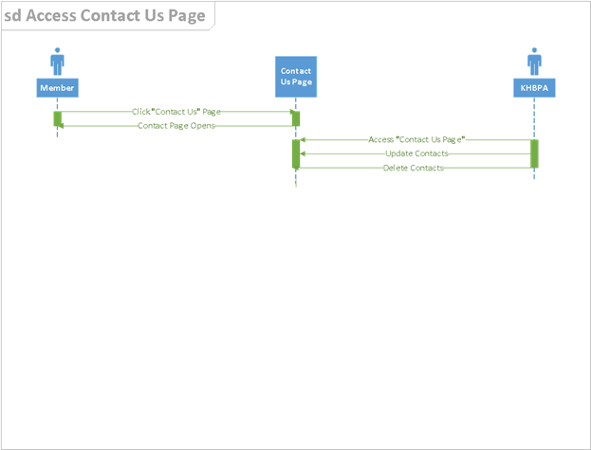

**Main Flow of Events:**

1. Member/Non-Member clicks on “Contact Us” link.
2. Member/Non-Member are brought to Contact Page.

**Use Case Name:** Accessing Documents Page **ID:** 12 **Importance Level:** High

**Primary Actor:** Members **Use Case Type:** Detail, Essential

**Stakeholders and Interests**:

KHBPA - Want a place to host documents for members, and a place to store filed documents from members.

Members - Want a way to download blank documents, and a method to upload completed documents to the KHBPA website.

**Brief Description:** This page will host documents that the members can search through and select. They will then be able to download the form(s) directly. After this, they can upload their completed form onto the KHBPA website. Once upload is successful, the user then makes a payment and the KHBPA will file the form.

**Trigger:** Member searches for forms.

**Type:** External

**Relationships**:

**Association:** Members, KHBPA

**Include**:

**Extend:**

**Generalization:** Homepage

**Normal Flow of Events:**

1. Member clicks “Forms” link on homepage.
2. Member searches forms.
3. Member makes a selection.
4. Member downloads form.
5. Member uploads form.
6. Member makes payment for upload.

**Sub Flows:**

S-1: KHBPA Searches Form

1. KHBPA clicks “Forms” link on homepage.
2. KHBPA searches forms based on Member’s inputs.
3. KHBPA makes a selection.
4. KHBPA downloads form.
5. KHBPA sends form to Member.
6. Member fills out the form.
7. If Member uploads the form

Member makes payment for upload.

8. If Member sends form back to KHBPA.

KHBPA collects payment from Member.

This diagram shows the interactions between classes in the Accessing Documents Page use case. Interactions are arrows which are labeled.

**Main Flow of Events:**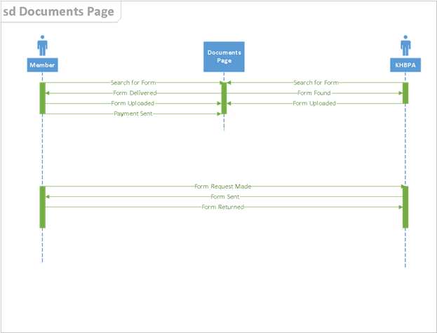

1. Member clicks “Forms” link on homepage.
2. Member searches forms.
3. Member makes a selection.
4. Member downloads form.
5. Member uploads form.
6. Member makes payment for upload.

**Use Case Name:** Accessing Calendar Page **ID:** 13 **Importance Level:** Medium

**Primary Actor:** Member/Non-Member **Use Case Type:** Essential

**Stakeholders and Interests**:

KHBPA - Want a way to display upcoming events in an easy-to-read format.

Members/Non-Members -Want a way to learn about upcoming events (or past events).

**Brief Description:** This shall be an organized calendar of KHBPA events. There will be a way to view the National HBPA calendar.

**Trigger:** Users click on “Events/Calendar” page link.

**Type:** External

**Relationships**:

**Association:** KHBPA

**Include**:

**Extend:**

**Generalization:** Homepage

**Normal Flow of Events:**

1. Users click on “Events/Calendar” page link.
2. Users are taken to the current calendar, which is published by the KHBPA.

This diagram shows the interactions between classes in the Accessing Calendar Page use case. Interactions are arrows which are labeled. 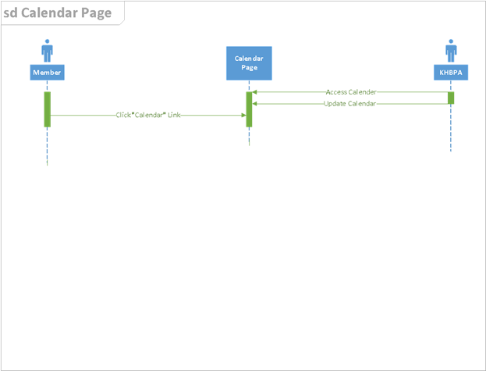

**Main Flow of Events:**

1. Users click on “Events/Calendar” page link.
2. Users are taken to the current calendar, which is published by the KHBPA.

**Use Case Name:** Learn How to Push for Legislation **ID:** 14 **Importance Level**: Medium

**Primary Actors**: KHBPA members **Use Case Type:** Detail, Essential

**Stakeholders and Interests**:

Members - want to contribute to the KHBPA’s legislative efforts

KHBPA - needs help in achieving their goals

**Brief Description**: This feature will allow users to help the KHBPA with issues in the horseracing community.

**Trigger**: Member clicks link to page

**Type**: External

**Relationships**:

**Association:**

**Include:**

**Extend:**

**Generalization:**

**Normal Flow of Events:**

1. Member visits site
2. Opens link to visit page
3. Finds out how they can get involved

Legislation Sequence Diagram

The sequence diagrams visualize the series of events that occur when the user requests something from the system. For this sequence diagram, the activist expresses interest in helping the KHBPA with legislation.

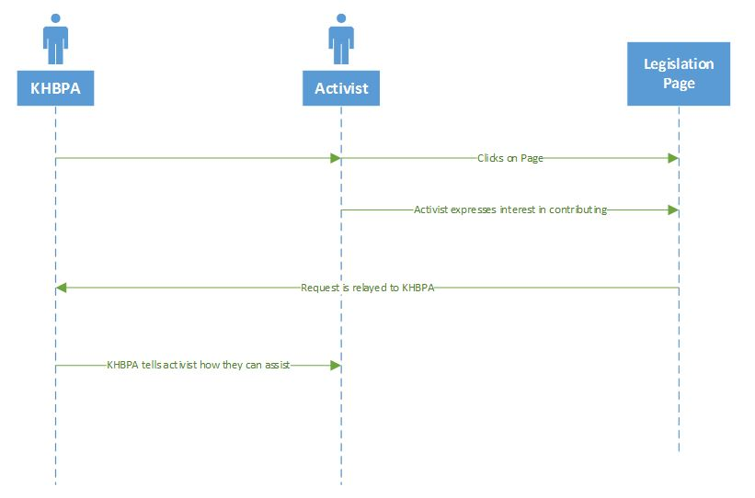

**Main Flow of Events:**

1. Member visits site
2. Opens link to visit page
3. Finds out how they can get involved

**Use Case Name:** Access FAQ’s **ID:** 15 **Importance Level**: Low

**Primary Actors**: KHBPA Members **Use Case Type:** Detail, Essential

**Stakeholders and Interests**:

Members- want to find answers to questions

Visitors- users who want to know specific things about the KHBPA

**Brief Description**: This use case describes a section for users to post questions and find answers.

**Trigger**: Member clicks link to page

**Type**:

**Relationships**:

**Association:**

**Include:**

**Extend:**

**Generalization:**

**Normal Flow of Events:**

1. Members and users visit site
2. Open the FAQ’s page
3. Ask/read questions or answers

FAQ Sequence Diagram

This sequence diagram shows how the user posts a question/reads an answer and how the KHBPA receives user-submitted questions. 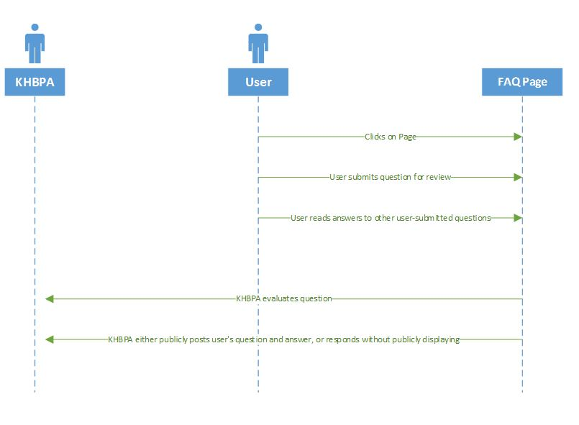

**Main Flow of Events:**

1. Members and users visit site
2. Open the FAQ’s page
3. Ask/read questions or answers

**Use Case Name:** Accessing Racing Education page    **ID:** 16 **Importance Level**: Low

**Primary Actors**: KHBPA Members **Use Case Type:** Detail, Essential

**Stakeholders and Interests**:

KHBPA - want to educate racing

Members - want to learn about racing

**Brief Description**: This use case describes how users access the racing education page.

**Trigger**: Member clicks link to page

**Type**: External

**Relationships**:

**Association:**

**Include:**

**Extend:**

**Generalization:**

**Normal Flow of Events:**

1. Member clicks on page.
2. Member browses page to learn about racing.

Racing Education Sequence Diagram

This sequence diagram shows how a visitor or a member can access a racing education page to learn more about horseracing.

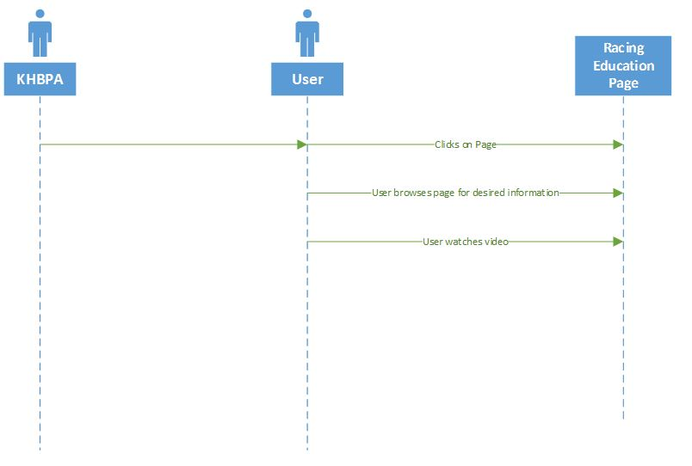

**Main Flow of Events:**

1. Member clicks on page.
2. Member browses page to learn about racing.

**Use Case Name:** Accessing Trainers Page **ID:** 17 **Importance Level**: Low

**Primary Actors**: Trainers, KHBPA **Use Case Type:** Detail, Essential

**Stakeholders and Interests**:

KHBPA - wants to give trainers their own page

Trainers - want to access specified page

Members - want to access page for trainers

**Brief Description**: This use case describes how users access the trainers page.

**Trigger**: Member clicks link to page

**Type**: External

**Relationships**:

**Association:**

**Include:**

**Extend:**

**Generalization:**

**Normal Flow of Events:**

1. User clicks page button.
2. The user accesses the trainers page.

Trainers Page Sequence Diagram

This sequence diagram shows how trainers can interact with each other in a page akin to a forum.

**Main Flow of Events:**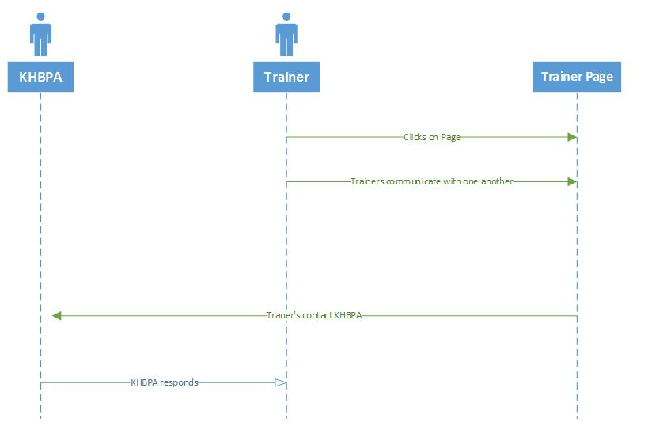

1. User clicks page button.
2. The user accesses the trainers page.

**Use Case Name:** View Photo Gallery **ID:** 18 **Importance Level:** Low

**Primary Actor:** Members, Potential Members **Use Case Type:** Detail, Essential

**Stakeholders and Interests**:

Member/Potential Member – wants to view the products and effort of the KHBPA

KHBPA – wants to display their involvement in the community

**Brief Description:** This use case describes how members and potential members can view the KHBPA community involvement

**Trigger:** Member/potential member clicks a link to a photo gallery

**Type:** External

**Relationships**:

**Association:** Member, potential member

**Include**:

**Extend:**

**Generalization:**

**Normal Flow of Events:**

1. User access KHBPA website.
2. User clicks on link to photo gallery.
3. User views photo.
4. User clicks an arrow to view the next photo.

This diagram shows the interactions between classes in the View Photo Gallery use case. Interactions are arrows which are labeled.

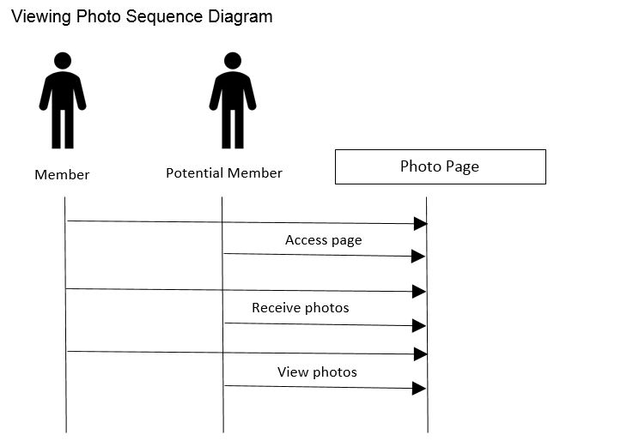

**Main Flow of Events:**

1. User access KHBPA website.
2. User clicks on link to photo gallery.
3. User views photo.
4. User clicks an arrow to view the next photo.

**Use Case Name:** View Track Information **ID:** 19 **Importance Level:** Low

**Primary Actor:** Members, Potential Members **Use Case Type:** Detail, Essential

**Stakeholders and Interests:**

Member – Wants to gain information on horse tracks involved with the KHBPA

KHBPA – Wants to allow members to access information on horse tracks they are involved with

**Brief Description:** This use case describes how members can gain information on horse tracks involved with the KHBPA.

**Trigger:** Member/potential member clicks on a link with a track name.

**Type:** External

**Relationships**:

**Association:** Member, Potential Member

**Include**:

**Extend:**

**Generalization:**

**Normal Flow of Events:**

1. User clicks on a track name link.
2. Information about the track is displayed.
3. User reads provided information.

This diagram shows the interactions between classes in the View Track Information use case. Interactions are arrows which are labeled.

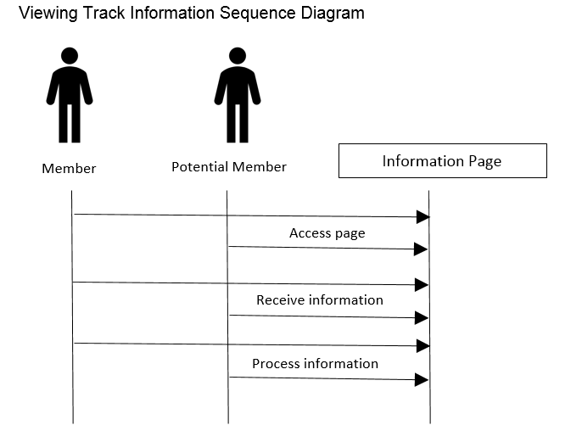

**Main Flow of Events:**

1. User clicks on a track name link.
2. Information about the track is displayed.
3. User reads provided information.

**Use Case Name:** View Other HBPA Chapter Information **ID:** 20 **Importance Level:** Low

**Primary Actor:** KHBPA Members **Use Case Type:** Detail, Essential

**Stakeholders and Interests:**

Member– Wants to gain information about another HBPA chapter

KHBPA – Wants to provide information to members involved in further involvement

**Brief Description:** Members that may be engaging in activities in another state may need information about the chapter of the HBPA in that state.

**Trigger:** User clicks on a link with the name of another chapter

**Type:** External

**Relationships**:

**Association:** Member

**Include**:

**Extend:**

**Generalization:**

**Normal Flow of Events:**

1. User clicks on a chapter name link
2. User is provided information of another chapter
3. User reads provided information

This diagram shows the interactions between classes in the View Other HBPA Chapter Information use case. Interactions are arrows which are labeled.

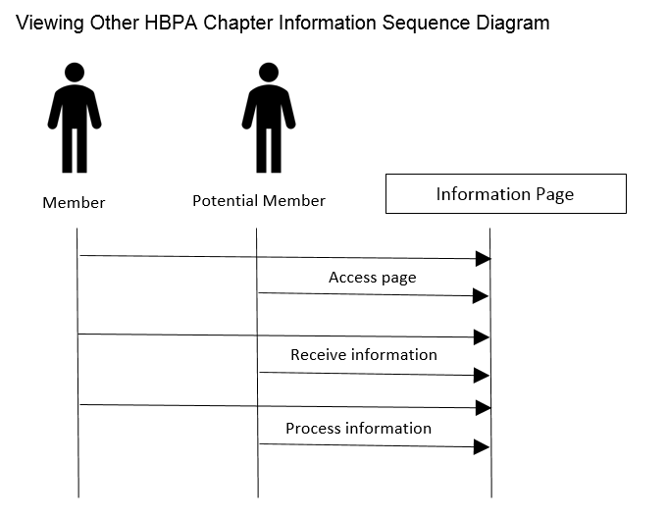

**Main Flow of Events:**

1. User clicks on a chapter name link
2. User is provided information of another chapter
3. User reads provided information

**Use Case Name:** Request Information **ID: 21 Importance Level:** Medium

**Primary Actor:** Members **Use Case Type:** Detail, Essential

**Stakeholders and Interests:**

Member – Wants to request specific information be added by the KHBPA

KHBPA – wants to provide as much specific information to its members as possible

**Brief Description:** This use case describes members can request information be added by the KHBPA.

**Trigger:** User clicks a submit request button.

**Type:** External

**Relationships**:

**Association:** Member, KHBPA

**Include**:

**Extend:**

**Generalization:**

**Normal Flow of Events:**

1. User clicks a submit request.
2. A request page with text input box is displayed.
3. User types request into the box.
4. Click submit button.
5. KHBPA receives the request in email form.
6. KHBPA adds information to appropriate section.

This diagram shows the interactions between classes in the Request Information use case. Interactions are arrows which are labeled.

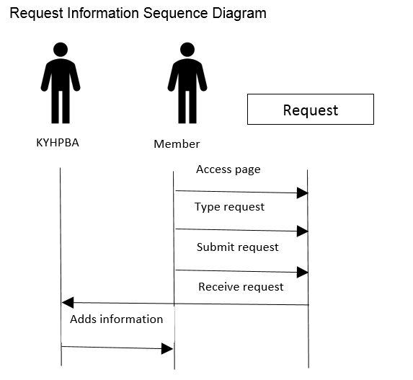

**Main Flow of Events:**

1. User clicks a submit request.
2. A request page with text input box is displayed.
3. User types request into the box.
4. Click submit button.
5. KHBPA receives the request in email form.
6. KHBPA adds information to appropriate section.

**Use Case Name:** Subscribe to Newsletter **ID:** 22 **Importance Level:** Medium

**Primary Actors**: KHBPA Members **Use Case Type:** Detail, Essential

**Stakeholders and Interests**:

Members- need to be able to subscribe to and receive digital newsletter

KHBPA - create electronic newsletter regularly

**Brief Description**: This use case describes how users subscribe to the KHBPA newsletter.

**Trigger**: User clicks a Subscribe-to-Newsletter button.

**Type**: External

**Relationships**:

**Association:** KHBPA Members

**Include:**

**Extend:**

**Generalization:**

**Normal Flow of Events:**

1. User clicks a Subscribe-to-Newsletter button.
2. A subscription page with multiple text input boxes is displayed.
3. User types their name and email address into the boxes.
4. User clicks submit button.
5. User is added to an email listserv.

**Subscribe to Newsletter Sequence Diagram**

This diagram shows the interactions between classes in the Subscribe to Newsletter use case. Interactions are arrows which are labeled.

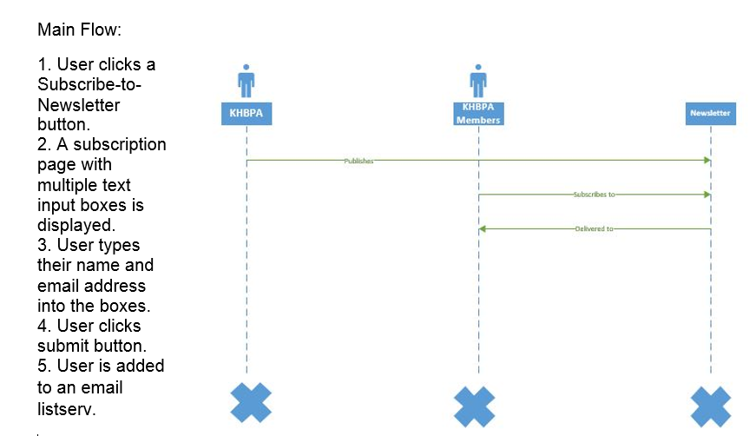

**Use Case Name:** Access News Archives **ID:** 23 **Importance Level:** Medium

**Primary Actors**: KHBPA Members and Potential Members **Use Case Type:** Detail, Essential

**Stakeholders and Interests**:

Members - need to be able to access news archives for reference

Potential Members - need to be able to access news archives for reference

KHBPA - archive relevant news regularly

**Brief Description**: This use case describes how users access news archives.

**Trigger**: User clicks a News Archives button.

**Type**: External

**Relationships**:

**Association:** KHBPA Members and Potential Members

**Include:**

**Extend:**

**Generalization:** Access News

**Normal Flow of Events:**

1. User clicks on News Archives button.
2. A page with months and years appears of all archived news.
3. User clicks the month and year they would like to access or the year they would like to access, if article is older than a year old.
4. A page with links to all news from that month and year appears.
5. User clicks title of article they would like to read.
6. Archived article user desires to read appears.

**Access News Archives Sequence Diagram**

This diagram shows the interactions between classes in the Access News Archives use case. Interactions are arrows which are labeled.

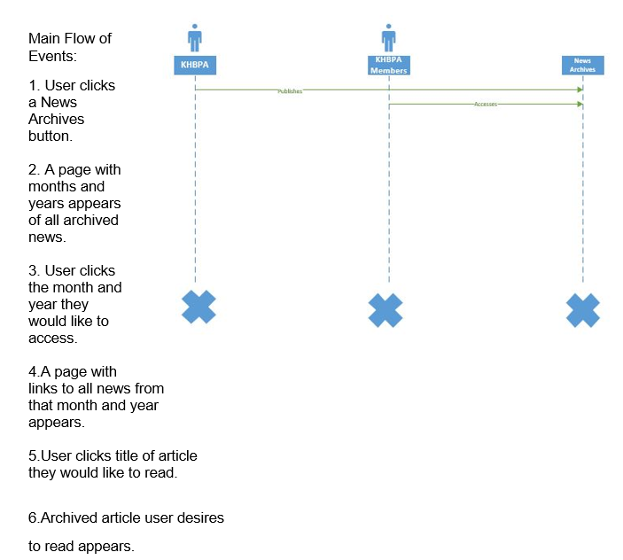

**Use Case Name:** Post Photos **ID:** 24 **Importance Level:** Low

**Primary Actors**: KHBPA Members **Use Case Type:** Detail, Essential

**Stakeholders and Interests**:

Members - want to post relevant photos

KHBPA - want to foster a horsemen community that can share memories and photos

**Brief Description**: This use case describes how users upload photos to the website that must be approved by a KHBPA employee.

**Trigger**: User clicks an Upload Photo button.

**Type**: External

**Relationships**:

**Association:** KHBPA Members

**Include:**

**Extend:**

**Generalization:**

**Normal Flow of Events:**

1. User clicks Upload Photo button.
2. User is directed to a page with text boxes for user information.
3. A dialog box appears asking for the photo’s location on the user’s computer.
4. User clicks the photo they would like to upload.
5. User fills out name and email information in text boxes.
6. User clicks a Submit Photo button (will not upload unless name and email information are filled out).
7. KHBPA employee receives an email notification that user is attempting to post photo.
8. KHBPA employee clicks Approve Button or Disapprove Button on email.
9. If Approve Button is clicked, photo is uploaded to photo gallery page.
10. If Disapprove Button is clicked, photo is deleted.

**Post Photos Sequence Diagram**

This diagram shows the interactions between classes in the Post Photos use case. Interactions are arrows which are labeled.

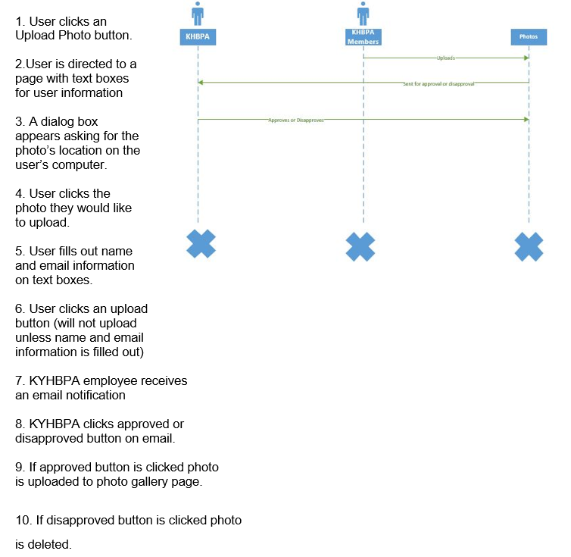

**Use Case Name:** Access Jennie Rees’ Blog **ID:** 25 **Importance Level:** Low

**Primary Actors**: KHBPA Members and Potential Members

**Stakeholders and Interests**:

Members - want to read Jennie Rees’ blog

Potential Members - want to read Jennie Rees’ blog

Jennie Rees - wants to write a blog for KHBPA members and potential members to read

**Brief Description**: This use case describes how users can access Jennie Rees’ blog to read.

**Trigger**: User clicks a button that links to Jennie Rees’ blog.

**Type**: External

**Relationships**:

**Association:** KHBPA Members and Potential Members

**Include:**

**Extend:**

**Generalization:**

**Normal Flow of Events:**

1. User clicks on button that links to Jennie Rees’ blog.
2. A page appears with the latest post from Jennie Rees’ blog and months and years of her past postings.
3. If user wants to read past blog posts, they click the month and year they would like to read.
4. A page appears of all blog postings from that month and year.
5. User clicks the title they would like to read.
6. A page appears with the blog post they clicked on.

**Access Jennie Rees’ Blog Sequence Diagram**

This diagram shows the interactions between classes in the Access Jennie Rees’ use case. Interactions are arrows which are labeled.

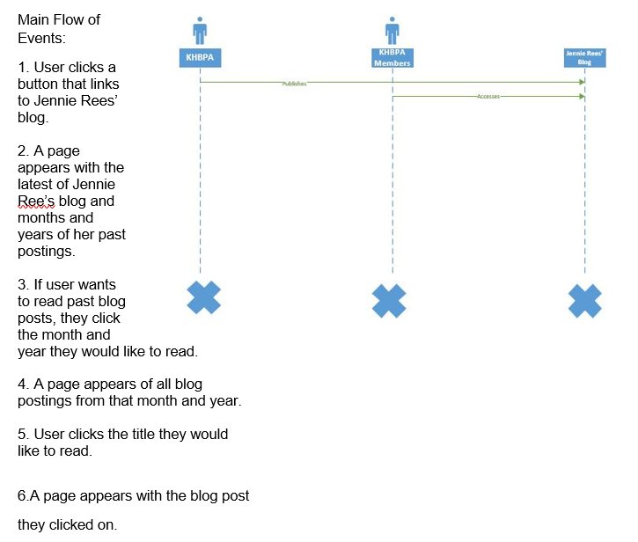

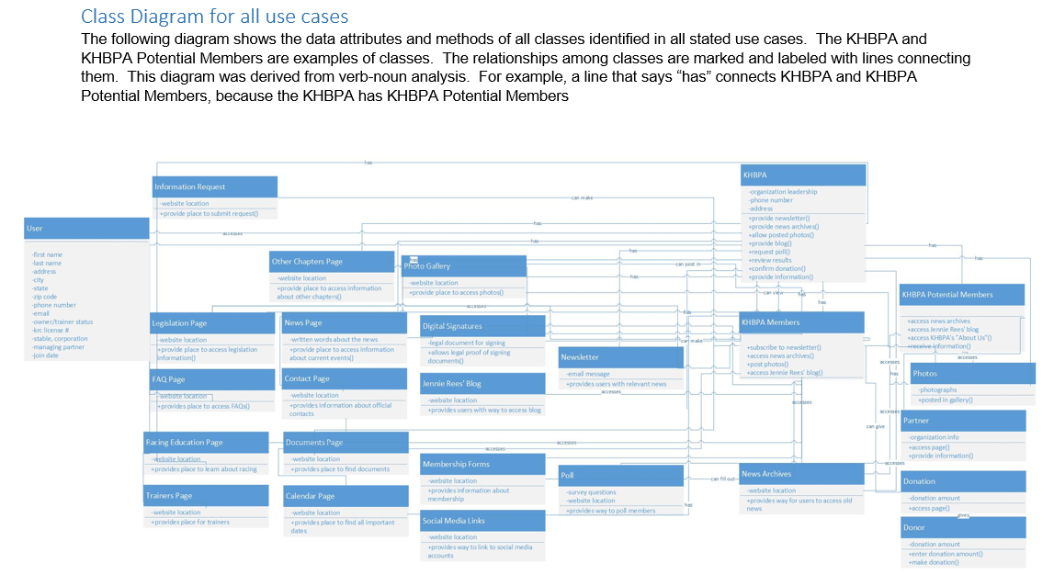

**DATA DICTIONARIES**

**Narrative**: These tables collectively form the KHBPA database which stores information about its users as well as other vital business functions.

|  |  |  |  |  |
| --- | --- | --- | --- | --- |
| KHBPA MEMBERS TABLE | | | | |
| **Field** | **Average Size (in characters)** | **Description** | **Type** | **Primary/Foreign Key** |
| Member ID | 3 | unique id number for each member | short text | Primary Key |
| Last Name | 13 | Last Name of the member | short text | - |
| First Name | 9 | First name of the member | short text | - |
| State | 2 | the state where the member lives | short text | - |
| Zip Code | 5 | the member's zip code | short text | - |
| Address | 45 | the member's home address | short text | - |
| Phone | 8 | member's preferred phone number | short text | - |
| Email | 25 | Member's preferred email address | short text | - |
| Member Since | 11 | Date member first enrolled | Date/Time | - |
| Owner | 2 | Is member an owner | Yes/No | - |
| Trainer | 2 | Is member a trainer | Yes/No | - |
| Owner/Trainer | 2 | Is member an owner and a trainer | Yes/No | - |
| KRC License Number | 4 | Kentucky Racing Commission license number | short text | - |
| Stable, Farm or Corporation (if Applicable) | 10 |  | short text | - |
| Managing Partner | 10 | Who is the managing partner for the member | short text | - |
| Digital Signature | 2 | Was digital signature submitted | Yes/No | - |

**Narrative**: The table stores the winnings and whether a KHBPA horse won or not

|  |  |  |  |  |
| --- | --- | --- | --- | --- |
| KHBPA PURSE TABLE | | | | |
| **Field** | **Average Size (in characters)** | **Description** | **Type** | **Primary/Foreign Key** |
| Purse ID | 2 | ID for distinguishing each winner | short text | Primary Key |
| Track ID | 2 | ID for each race track | short text | Foreign Key |
| Winning Horse KHBPA Member? | 2 | Did a KHBPA member's horse win | Yes/No | - |
| Horse ID | 2 | ID of the horse that won | Winning HorseID (if relevant) (FK) | Foreign Key |
| Member ID | 3 | ID given to each member | WinningMemberID (if relevant) | Foreign Key |
| Purse Amount | 4 | Amount of money won | Currency | - |

**Narrative**: This table is for the various forms the KHBPA offers

|  |  |  |  |  |
| --- | --- | --- | --- | --- |
| KHBPA FORMS TABLE | | | | |
| **Field** | **Average Size (in characters)** | **Description** | **Type** | **Primary/Foreign Key** |
| Form ID | 2 | ID for each form | short text | Primary Key |
| Form Name | 6 | The name of the form that was filled out | short text | Foreign Key |
| Date of Revision | 6 | Date when form was edited | Date/Time | - |
| Cost of Form | 2 | Cost of filling out form | Currency | - |

**Narrative**: This table records the racetrack where a race occurred and the city where it took place

|  |  |  |  |  |
| --- | --- | --- | --- | --- |
| KHBPA TRACK TABLE | | | | |
| **Field** | **Average Size (in characters)** | **Description** | **Type** | **Primary/Foreign Key** |
| Track ID | 5 | The track where the race took place | short text | Primary Key |
| City | 10 | City where Track is located | short text | Foreign Key |

**Narrative**: This table stores information about who participated in a poll and which poll was conducted.

|  |  |  |  |  |
| --- | --- | --- | --- | --- |
| KHBPA POLLING TABLE | | | | |
| **Field** | **Average Size (in characters)** | **Description** | **Type** | **Primary/Foreign Key** |
| Polling ID | 2 | The poll that was conducted | short text | Primary Key |
| Member ID | 3 | Member who submitted answer to a poll | short text | Foreign Key |

**Narrative**: This is the Table for storing data about the horses connected to the KHBPA

|  |  |  |  |  |
| --- | --- | --- | --- | --- |
| KHBPA HORSES TABLE | | | | |
| **Field** | **Average Size (in characters)** | **Description** | **Type** | **Primary/Foreign Key** |
| Horse ID: | 2 | unique id number for each horse | short text | Primary Key |
| Horse Name: | 13 | The name of the horse | short text | - |
| Member ID: | 3 | unique id number for each member | short text | Foreign Key |
| Date of Birth: | 8 | Horse's birth date | Date/Time | - |
| Number of Races: | 2 | how many races has horse competed in | short text | - |

**Narrative:** This table is for storing data about claims that a member files

|  |  |  |  |  |
| --- | --- | --- | --- | --- |
| KHBPA CLAIMS TABLE | | | | |
| **Field** | **Average Size (in characters)** | **Description** | **Type** | **Primary/Foreign Key** |
| Claim ID: | 3 | unique id for each claim that is made | short text | Primary Key |
| Member ID | 3 | ID for each member | short text | Foreign Key |
| Form ID | 3 | unique ID for each form | short text | - |
| Date Filed | 6 | date when claim was submitted | Date/Time | - |

**Narrative**: This table stores information about how employees receive payment

|  |  |  |  |  |
| --- | --- | --- | --- | --- |
| KHBPA PAYROLL TABLE | | | | |
| **Field** | **Average Size (in characters)** | **Description** | **Type** | **Primary/Foreign Key** |
| Payroll ID | 2 | unique ID number for each horse | short text | Primary Key |
| Employee ID | 2 | The name of the horse | short text | Foreign Key |
| Bi-Weekly Pay | 3 | unique ID number for each member | Currency | - |

**Narrative**: This table shows whenever a transaction is made between the KHBPA and its members

|  |  |  |  |  |
| --- | --- | --- | --- | --- |
| KHBPA TRANSACTIONS TABLE | | | | |
| **Field** | **Average Size (in characters)** | **Description** | **Type** | **Primary/Foreign Key** |
| Transaction ID | 2 | ID for each transaction | short text | Primary Key |
| Member ID | 3 | ID for each member | short text | Foreign Key |
| Employee ID | 2 | ID for each employee | short text | Foreign Key |
| Form ID | 2 | ID for each form | short text | Foreign Key |
| Transaction Date | 8 | Date when transaction occurred | Date/Time | - |
| Cost | 3 | cost of | Currency | - |

**Narrative**: This table shows how many hours each employee works and when they worked

|  |  |  |  |  |
| --- | --- | --- | --- | --- |
| KHBPA HOURS WORKED TABLE | | | | |
| **Field** | **Average Size (in characters)** | **Description** | **Type** | **Primary/Foreign Key** |
| Hours Worked ID | 2 | ID for hours worked for each employee | short text | Primary Key |
| Employee ID | 2 | Unique ID for each employee | short text | Foreign Key |
| Worked Date | 6 | Days when employee worked | Date/Time | - |
| Hours Worked | 2 | Amount of time that employee worked | Number | - |

**Narrative**: This table stores information about the employees of the KHBPA

|  |  |  |  |  |
| --- | --- | --- | --- | --- |
| KHBPA TABLE | | | | |
| **Field** | **Average Size (in characters)** | **Description** | **Type** | **Primary/Foreign Key** |
| Employee ID | 2 | An employee's unique ID code | short text | Primary Key |
| Title | 10 | Employee's position in organization | short text | - |
| First Name | 9 | Employee's first name | short text | - |
| Last Name | 13 | Employee's last name | short text | - |
| Street Address | 45 | Employee's first name | short text | - |
| City | 25 | Employee's home address | short text | - |
| State | 2 | Employee's state where they reside | short text | - |
| Zip Code | 5 | Employee's Zip code | short text | - |
| Phone Number | 10 | Employee's preferred phone number | short text | - |
| Email Address | 25 | Employee's email address | short text | - |
| Salary | 4 | Does the employee have a salary | Yes/No | - |
| Hire Date | 8 | When was the employee hired | Date/Time | - |
| Pay Rate | 3 | How the employee is paid | Currency | - |

**Narrative**: This table is for storing data about the donations each member makes

|  |  |  |  |  |
| --- | --- | --- | --- | --- |
| KHBPA DONATION TABLE | | | | |
| Field | Average Size (in characters) | Description | Type | Primary/Foreign Key |
| DonationID | 2 | Unique ID for each donation made | short text | Primary Key |
| Member ID | 3 | Member who made donation | short text | Foreign Key |
| Donation Amount | 2 | Amount of money donated | Currency | - |

Entity-Relational Diagram (ERD)

The ERD (Entity Relationship Diagram) shows the connections between the tables and their attributes. We chose, what we considered to be, the necessities for the KHBPA in terms of recording donations, keeping records of polls conducted, data about the members, and other important considerations when creating the database. We used the class diagram as our blueprint for creating the database and then illustrating their connections via the ERD. The class User, for example, was used to construct the KHBPA Member table which contains information regarding each member of the KHBPA. Each member is given a unique ID to identify them and their names, addresses, phone numbers, and other important information about the KHBPA’s members are stored in the Table named KHBPA Member. The KHBPA table has information regarding the KHBPA staff. Throughout each table, we created primary and foreign keys to use for the ERD. We repeated this process for each table and then established their relationships. We categorized the attributes into tables and then converted them into 3NF or Third

Normal Form. Normalization is a process of eliminating redundancy and avoiding update, insertion, and deletion anomalies. You start by checking if the database is in 1NF, which means that there are no repeating fields, the primary keys are clearly defined, and all attributes are dependent on the primary key. The next step is to convert the database into 2NF, which means that there are no partial dependencies remaining. Partial dependencies are non-key attributes that are partially dependent on a candidate key. The final step is to convert the database into 3NF, which means that the transitive dependencies have been removed. A transitive dependency is when an attribute functionally depends on another non-key attribute. These were the steps we took for creating the ERD for the KHBPA.

Entity-Relationship Diagram

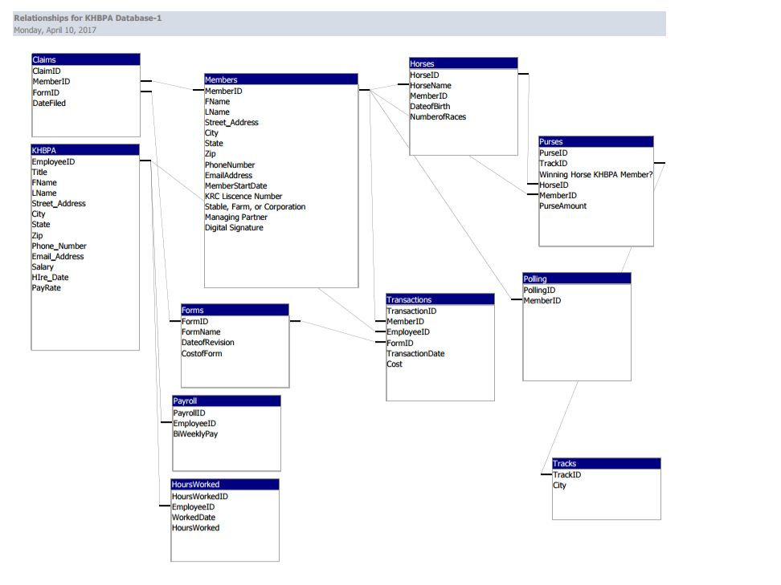

Windows Navigation Diagram

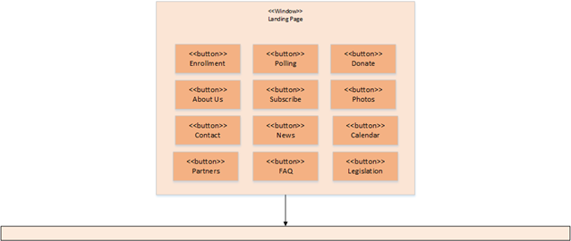

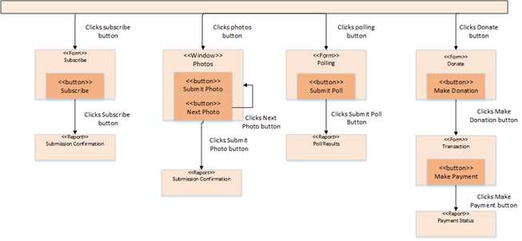

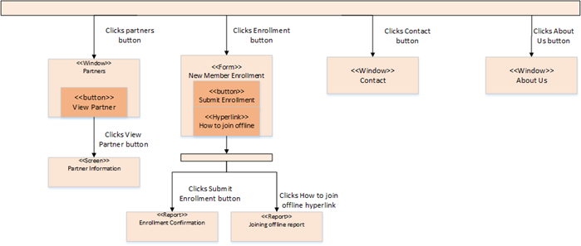

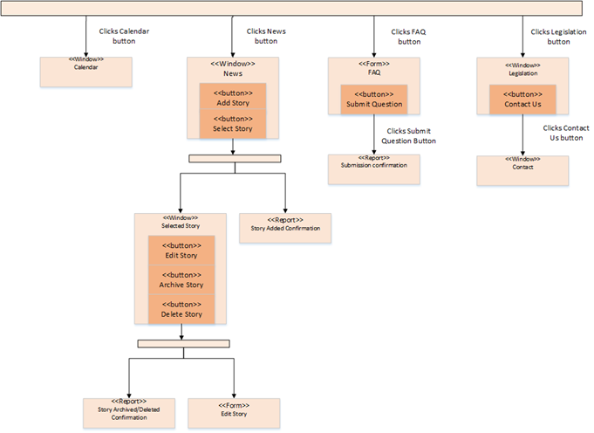

**Input Screen Layouts**

New Member Enrollment Form

This is what the new member enrollment form could look like. It captures all the required information for a person to join the KYHBPA.

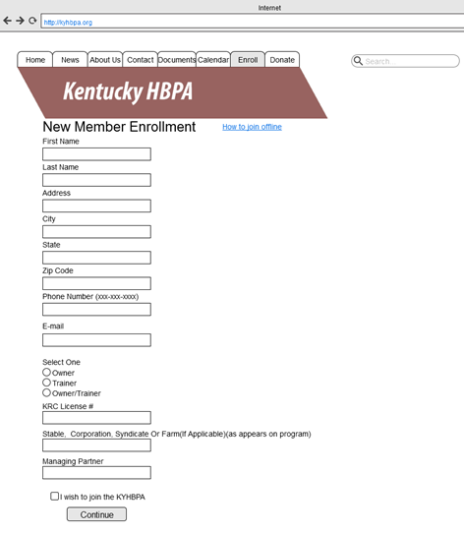

Polling Form

This screen realizes the use case by allowing the KHBA to collect information from its users on relevant topics.

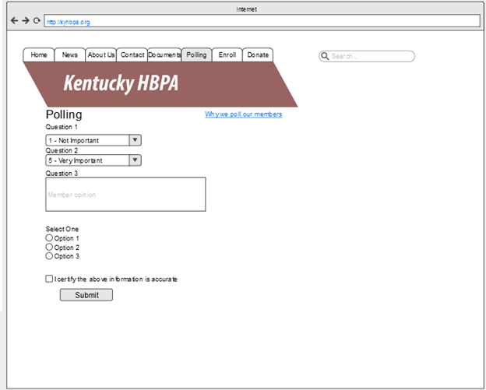

Subscribe Form

This screen realizes the use case by allowing a user to electronically subscribe to the KHBPA newsletter.

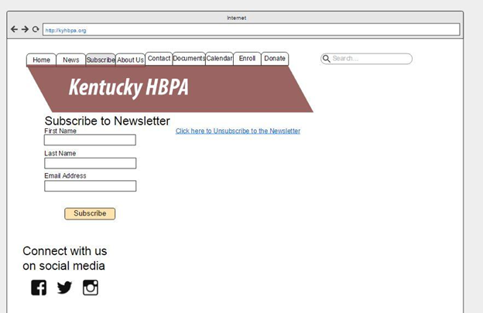

Donate Form

This screen realizes the use case by allowing a donor to make a donation online.

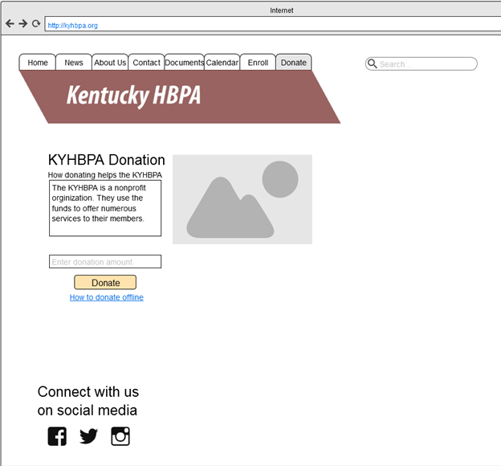

Transaction Form

This screen realizes the use case by allowing a payment to be made through an online payment processing system.

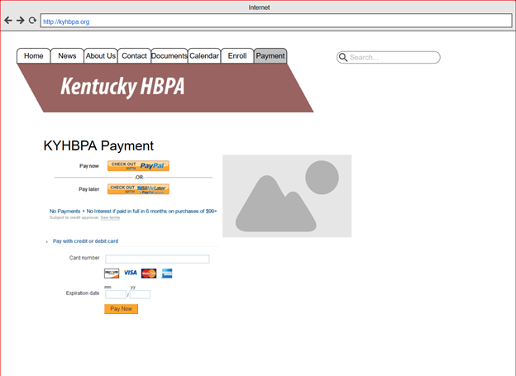

FAQ Form

This screen realizes the use case by allowing users to submit and view questions.

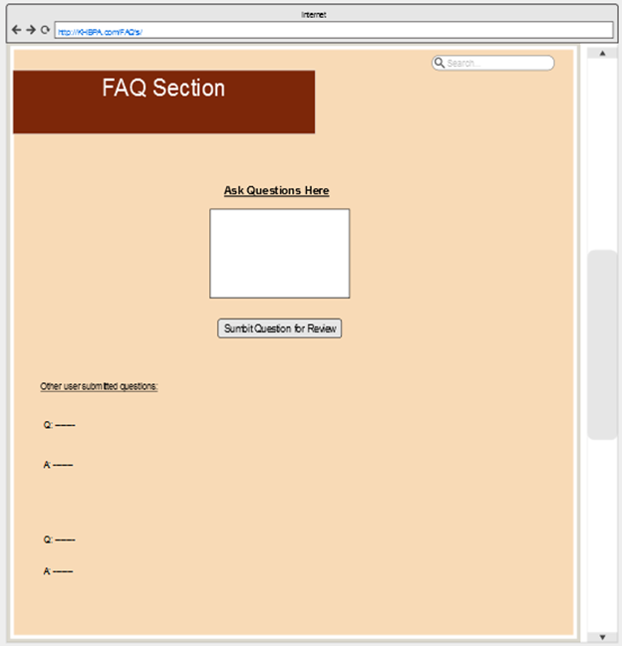

**Output Screen Layouts**

Provide screen layouts for input screens/forms (data capture) and output screens/reports (data presentation). Layouts may be borrowed from the HTML prototype (recommended) or presented in storyboard form. Explain how the screen layouts realize the use cases.

Joining Offline Report

This screen provides information about how to join the KYHBPA offline.

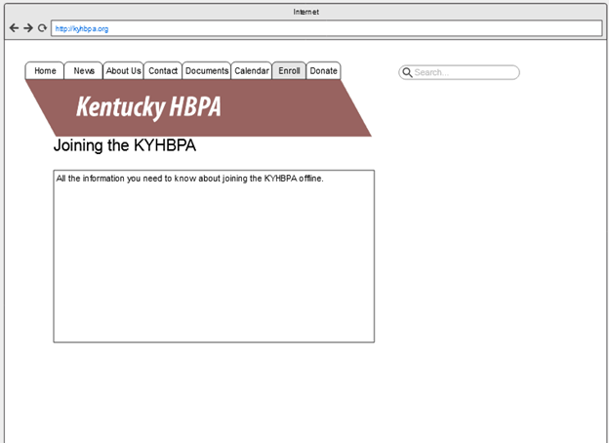

Partner Information Report

This screen realizes the use case by providing information about a selected partner.

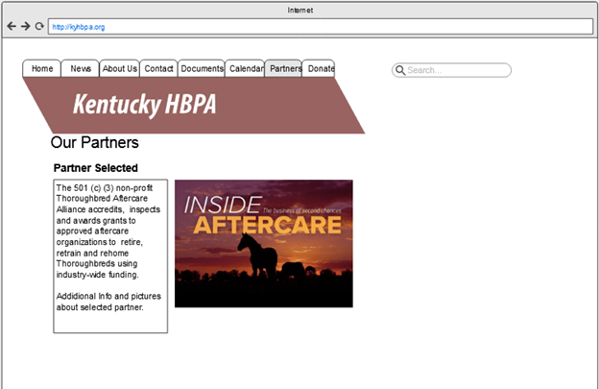

Contact Screen

This screen provides all the information users may need to contact the KYHBPA.

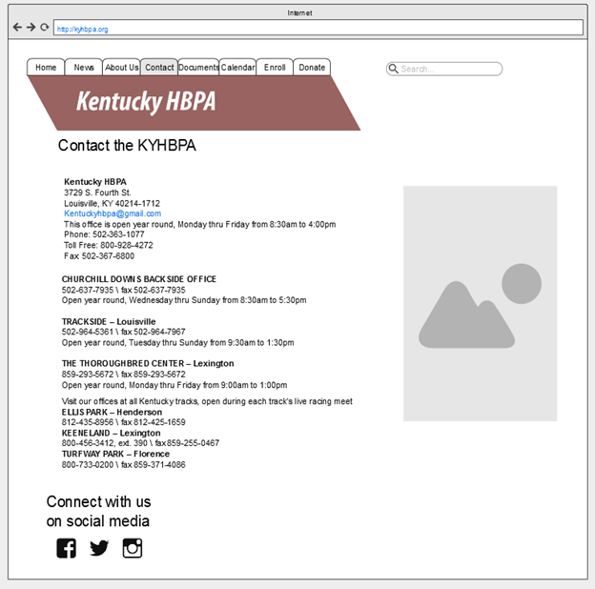

About Us Screen

This screen realizes the use case by providing information about the purpose and history of the KHBPA.

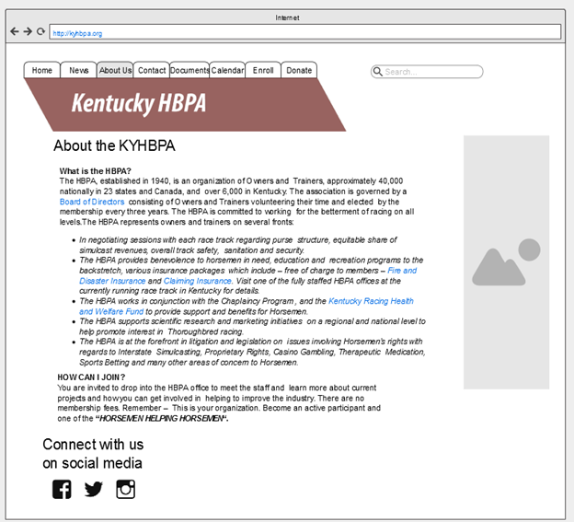

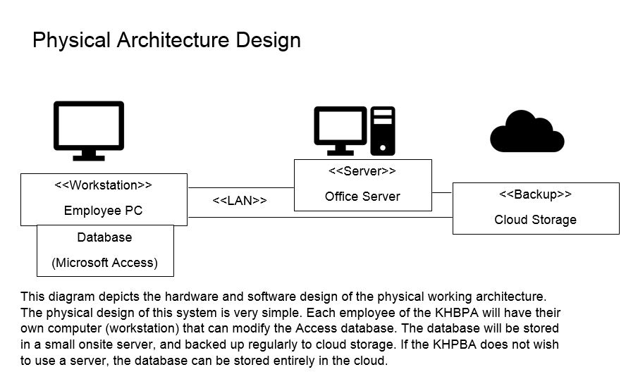

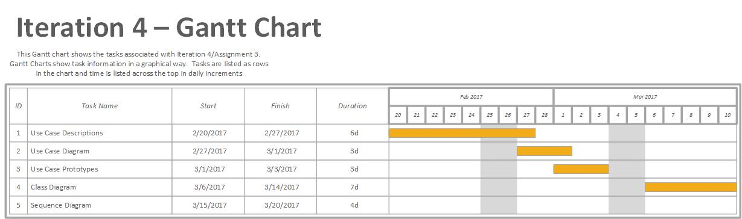

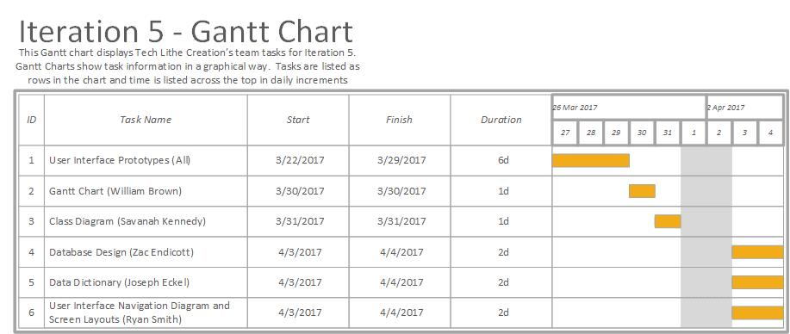

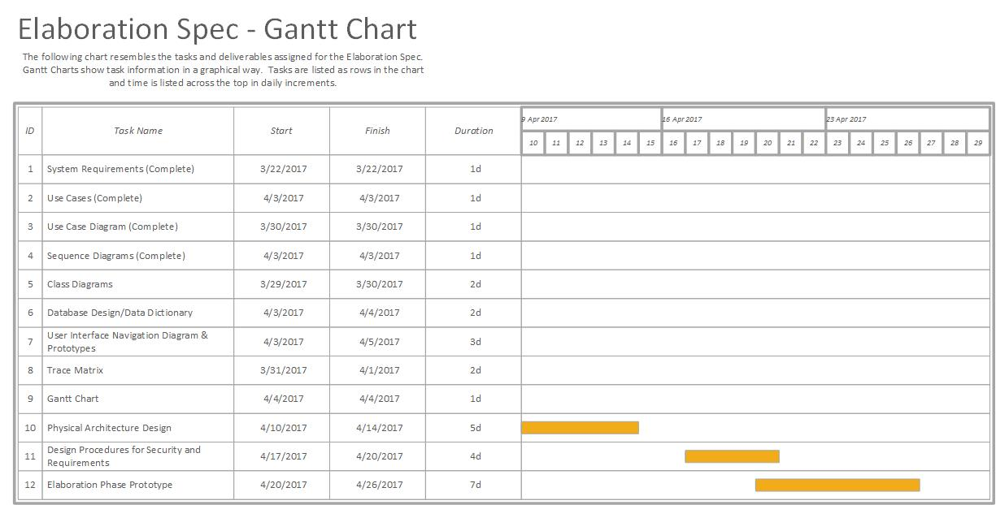

**Prototypes**

**Narrative**:

The following prototypes are designed as high-level layouts of the processes from the earlier described use cases. These are samples of what each page could possibly look like after the implementation of the new system.

Paying Transaction Online Prototype

This prototype shows a screen that the users may see when wanting to proceed with a payment transaction.

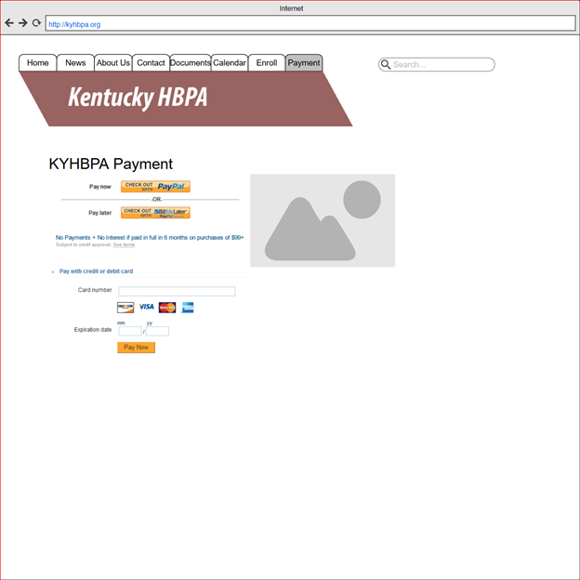

Submitting Forms for Membership Information Prototype

This prototype shows what the user may see when trying to submit forms for membership information.

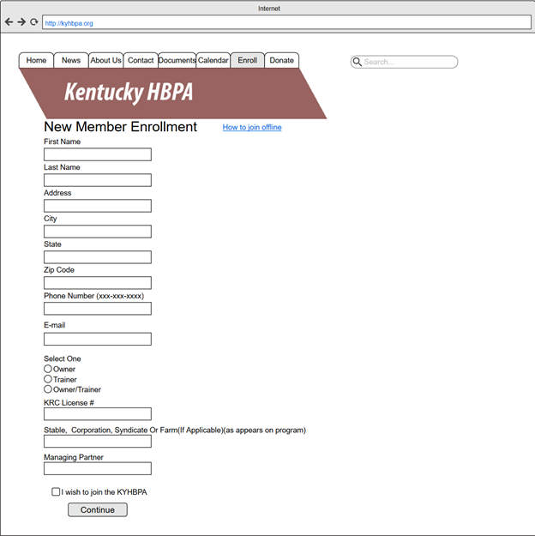

Displaying Social Media Links Prototype

This prototype shows how social media links may be displayed.

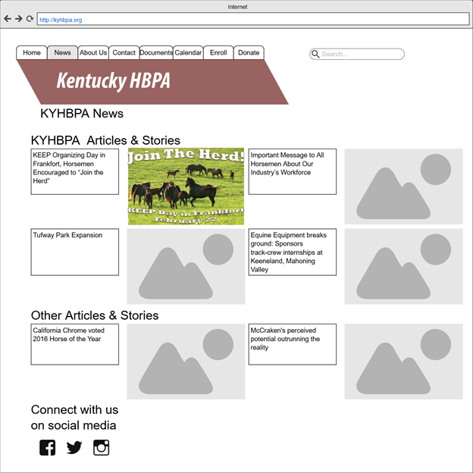

Submitting Digital Signatures Online Prototype

This prototype shows what the user may see when trying to submit a digital signature.

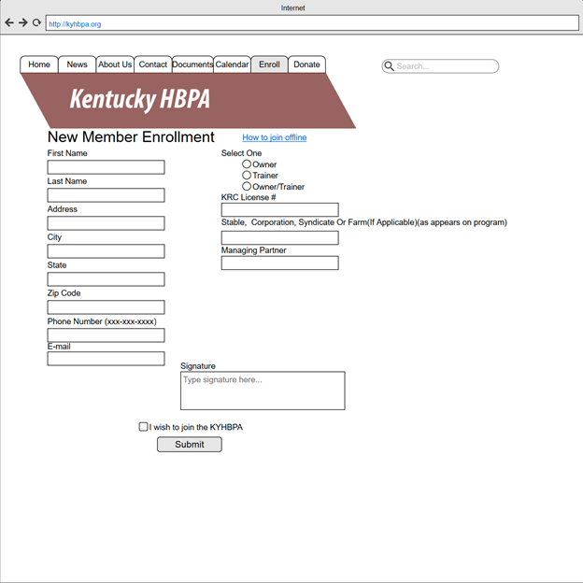

Making Online Donation Prototype

This prototype shows what a donation screen might look like. It has a textbox for a donor to enter their donation amount and a button that will take them to the online payment system.



Accessing Partner Organizations Prototype

This prototype shows what a partners screen might look like. It has links and information about organizations similar to the KYHBPA.

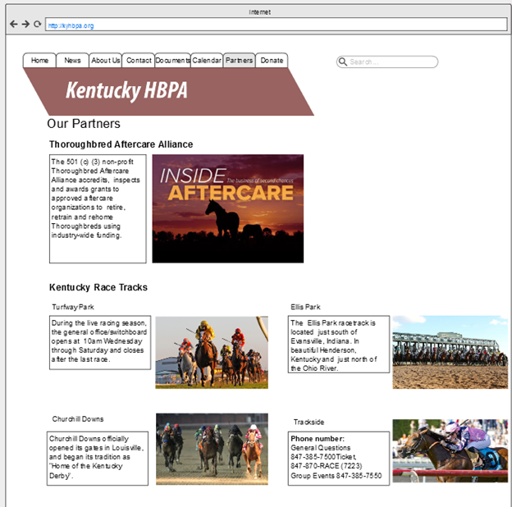

Accessing “About Us” Prototype

This prototype shows what an about us screen might look like. It has basic information about the KYHBPA and its purpose to inform members and potential members.



Polling Members Prototype

This screen shows what a polling page could look like. The questions could require drop down lists, text input, checkboxes, or radio buttons depending on the type of poll.



News Page Prototype

This prototype shows what the user may see when they are on the news page.

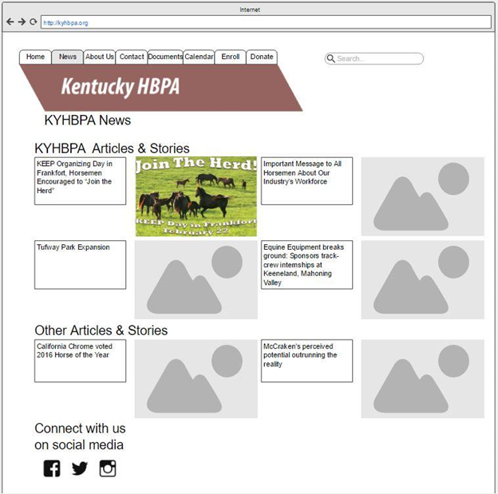

Contact Us Page Prototype

This prototype shows what the user may see when accessing the “contact us” page.

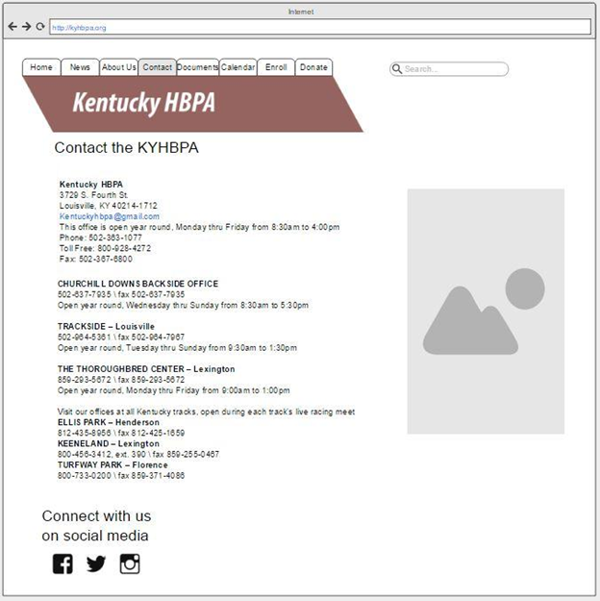

Documents Page Prototype

This prototype shows what users may see when accessing the documents page. There is a button to upload documents and a link to printable documents.

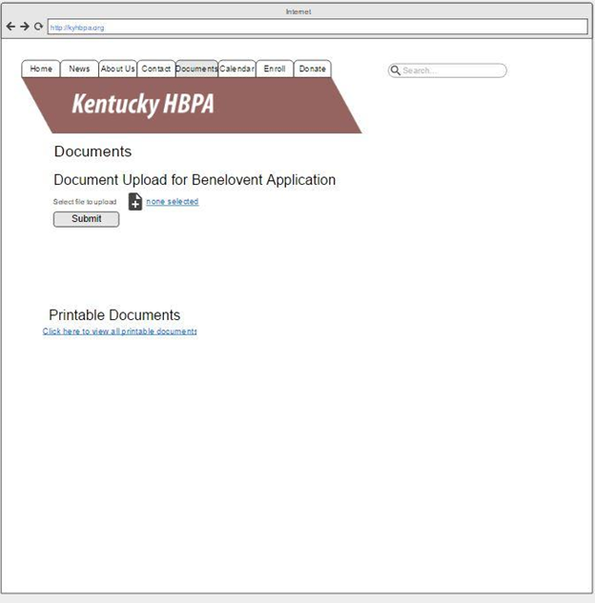

Legislation Page Prototype

This a wireframe example of how a page devoted to assisting the KHBPA with regards to legislation could look.

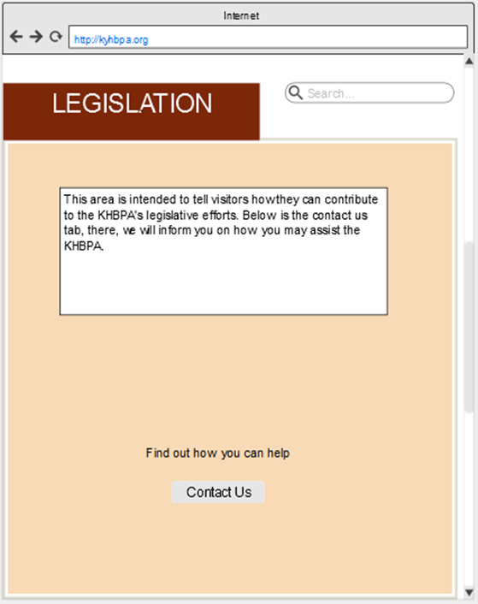

Accessing FAQ’s Prototype

This section is for the wireframe FAQ webpage.

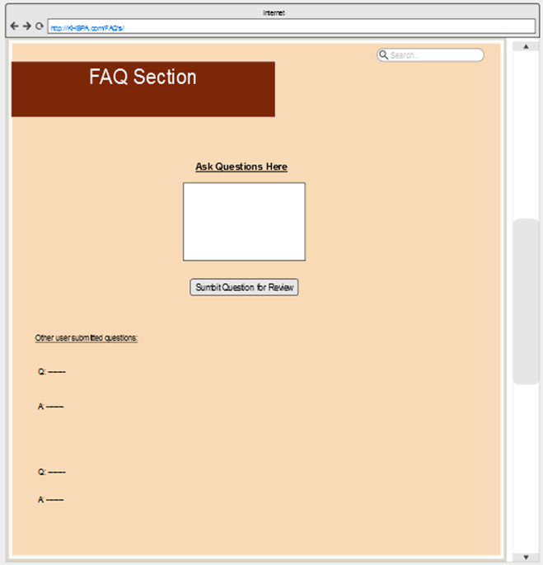

Accessing Racing Education Page Prototype

This is the prototype for a racing education page for anyone interested in learning more about the horseracing community.

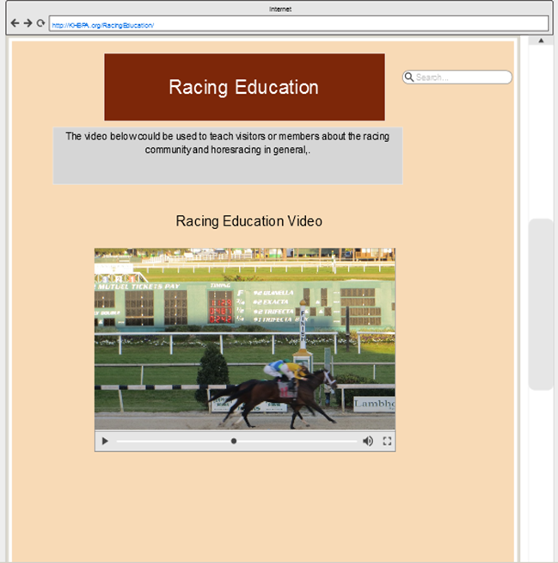

Accessing Trainers Page Prototype

This a prototype for the Trainer’s page, a forum of sorts, and a general sense of how this page could look.

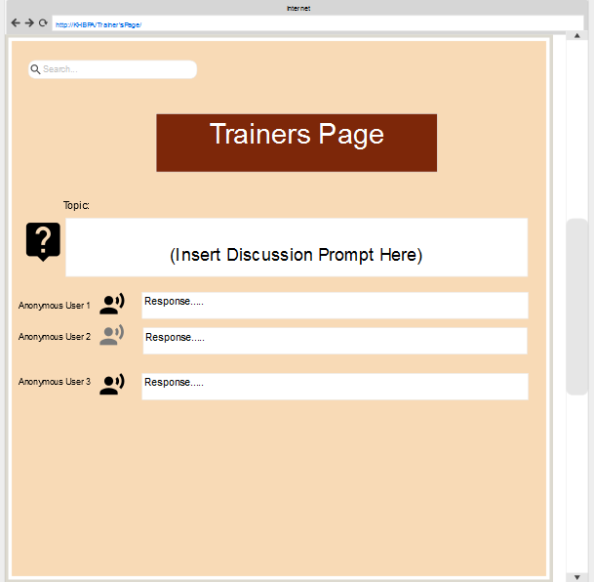

Making Online Donation Prototype

This prototype shows what a photo gallery might look like. It has photos and navigation arrows.

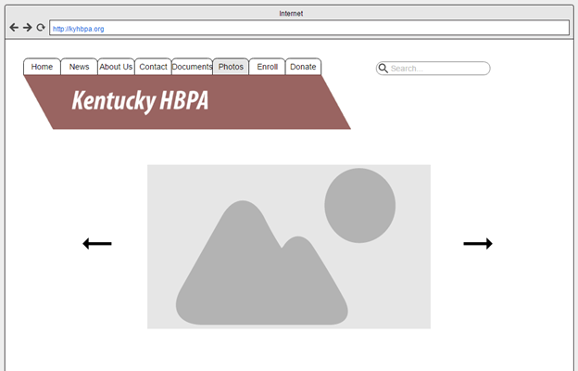

Accessing Track Information Prototype

This prototype shows what a track information screen might look like. It has links and information about tracks in Kentucky.

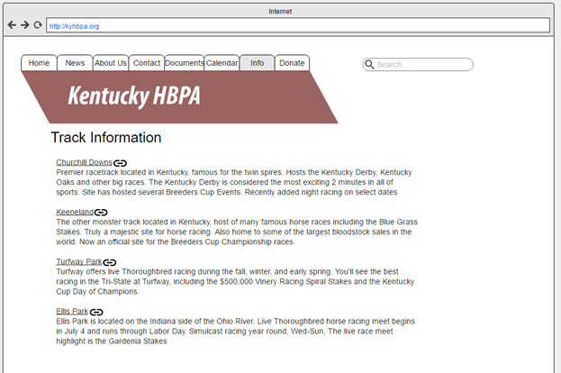

Accessing Other Chapters Prototype

This prototype shows what an information screen for other state chapters might look like. Links to the other chapters’ websites.

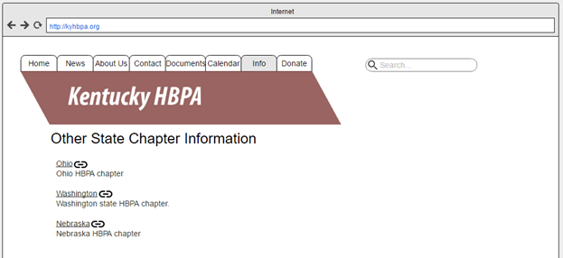

Request Information Prototype

This screen shows what an information request could look like. An entry box and submission button are present.

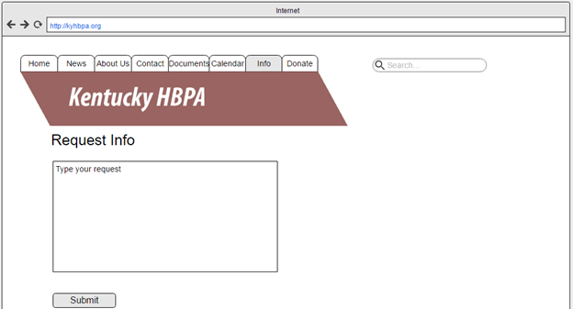

Subscribe to Newsletter Prototype

This prototype shows how subscribing to the newsletter could look. It has fields for the user’s first and last name and email address. The page also offers a link to unsubscribe to the newsletter.

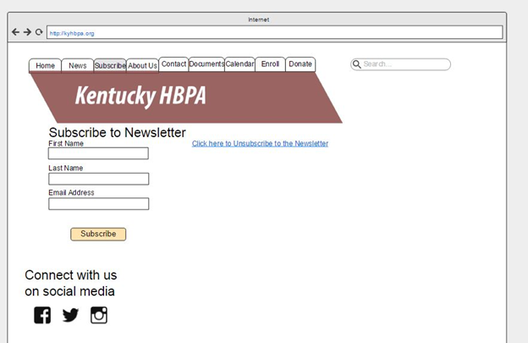

Access News Archives Prototype

This prototype shows what accessing the news archives could look like. It has a link to every month for the current and past year. It also has links to years past that, which can be clicked on to access a list of news archives from that date.

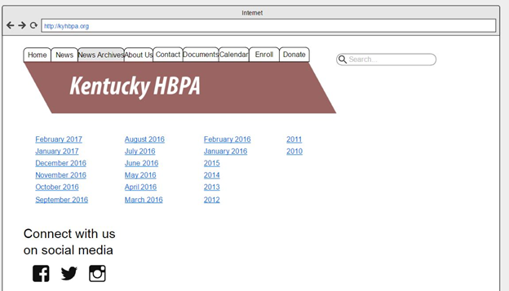

Particular Month News Archives Prototype

This prototype shows what could appear once a news archives month and year have been selected. This page would have all articles from its particular month and year. It also offers links to go back one month and to go forward one month.

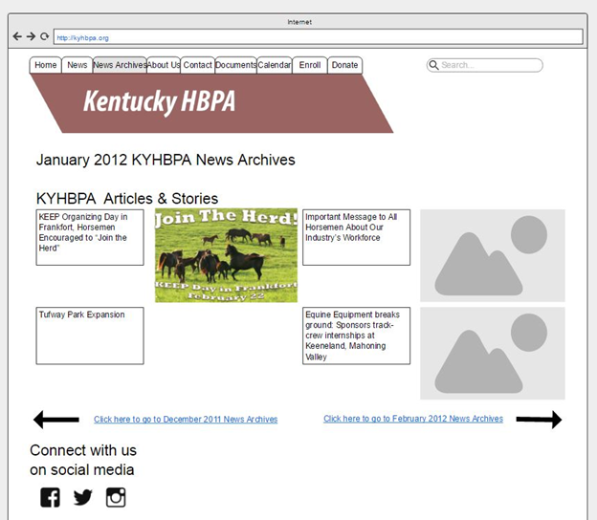

Post Photos Prototype

This prototype allows users to upload photos directly from their computer. It has text boxes for the user’s first and last name and email address, as well, so the KHBPA knows who is attempting to post a photo.

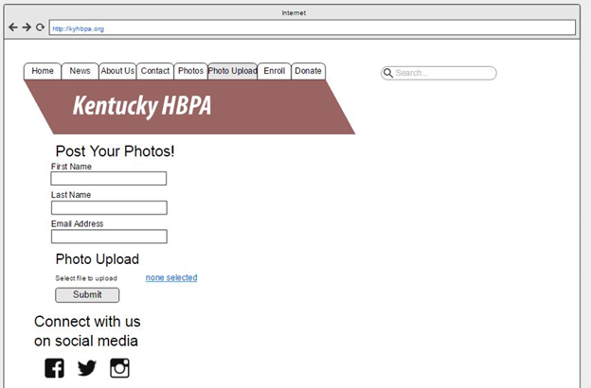

Access Jennie Rees’ Blog Prototype

This prototype shows what Jennie Rees’ blog page could look like. It highlights her latest post. It also has links to the months and years of her past posts.



            
            
            
           
         
          
            
            